**Nginx 反向代理**

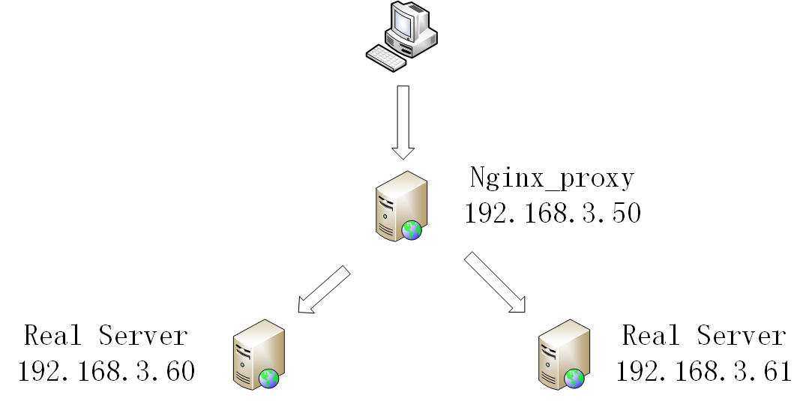

**Nginx proxy : 192.168.3.50**

**Real server : 192.168.3.60**

**Real server : 192.168.3.61**

**系统版本**

**Centos-6.5-x64-mini**

1. **分别在三台real server 上安装nginx**

**centos 6.5 安装nginx**

**nginx version: nginx/1.10.1**

**vi /etc/yum.repos.d/nginx.repo**

**[nginx]**

**name=nginx repo**

**baseurl=http://nginx.org/packages/OS/OSRELEASE/$basearch/**

**gpgcheck=0**

**enabled=1**

**Replace “OS” with “rhel” or “centos”, depending on the distribution used, and “OSRELEASE” with “5”, “6”, or “7”, for 5.x, 6.x, or 7.x versions,**

**respectively.**

**[nginx]**

**name=nginx repo**

**baseurl=http://nginx.org/packages/centos/6/$basearch/**

**gpgcheck=0**

**enabled=1**

**yum install nginx**

**nginx -v**

**whereis nginx**

**nginx: /usr/sbin/nginx /etc/nginx /usr/share/nginx**

**1 配置所在目录：/etc/nginx/**

**2 PID目录：/var/run/nginx.pid**

**3 错误日志：/var/log/nginx/error.log**

**4 访问日志：/var/log/nginx/access.log**

**5 默认站点目录：/usr/share/nginx/html**

**在192.168.3.60 上**

**Vi /usr/share/nginx/html/index.html**

**修改为**

**This is test page 192.168.3.60!!**

**在 192.168.3.61上**

**Vi /usr/share/ngin/html/index.html**

**修改为**

**This is test page 192.168.3.61!!**

**然后启动两台服务器的nginx 服务**

**Service nginx start**

**在192.168.3.50上 修改nginx 配置文件为下图**

**server {**

**listen 80;**

**server_name 192.168.3.50;**

**location /nginxstatus{**

**stub_status on;**

**access_log on;**

**auth_basic "nginxstatus";**

**auth_basic_user_file htpasswd;**

**}**

**location / {**

**index index.jsp;**

**proxy_pass http://test;**

**proxy_redirect off;**

**proxy_set_header Host $host;**

**proxy_set_header X-Real-IP $remote_addr;**

**proxy_set_header X-Forwarded-For $proxy_add_x_forwarded_for;**

**client_max_body_size 10m;**

**client_body_buffer_size 128k;**

**proxy_connect_timeout 300;**

**proxy_send_timeout 300;**

**proxy_read_timeout 300;**

**proxy_buffer_size 4k;**

**proxy_buffers 4 32k;**

**proxy_busy_buffers_size 64k;**

**proxy_temp_file_write_size 64k;**

**}**

**}**

**upstream test{**

**server 192.168.3.61:80 weight=1;**

**server 192.168.3.60:80 weight=1;**

**}**

**现在重新启动3.50 nginx 服务**

**通过http://192.168.3.50 访问 测试效果**

**刷新的时候可以看到3.60,3.61页面在轮询**

**至此 反向代理结束**